**Web project:** CompareJobOffers.net - CJO

**Requirements -** (Technical workers)

The key to this App is the user can have two scenarios; One compare multiple jobs offers, and secondly enter a fulltime time job offer to what it equates to hourly wages.

1. Create home page that introduces the CJO App and how it works
2. Add a “Getting Started” button to the home page
3. Create form to allow user enter profile info - including login
   1. Full Name
   2. Email address (will be used as username)
   3. City and State
   4. Education level – (HS, AA, BS, or PhD)
   5. Experience (no of years)
   6. Skills - /w number of years
   7. Rank training base of importance
4. Create a form the gather info about an offer – allow user to enter multiple offers
   1. Name of companies with offer
   2. Type of business
   3. Size (Fortune 100-500)
   4. State (select option)
   5. City (select base on state)
   6. Type of Offer - Fulltime/Contract (radio button)
   7. Pay base on – f (Annually/Hourly)
   8. Relocating – City/State
5. Create a report that priorities the offer base on
6. Create MySQL Database and tables - CJO-Model
   1. User
   2. Offers
   3. Job
   4. Education
   5. SkillProfile
   6. Lookup tables: - see CJO-Diagram 1.0 (below0
      1. City/State cost of living (City1 to City2)
      2. Companies – if possible
      3. Skills
      4. Job type and area
      5. Pay base on job type
      6. Weighted value you table
      7. Tax table – state with no income
      8. Sector / Positions /Major

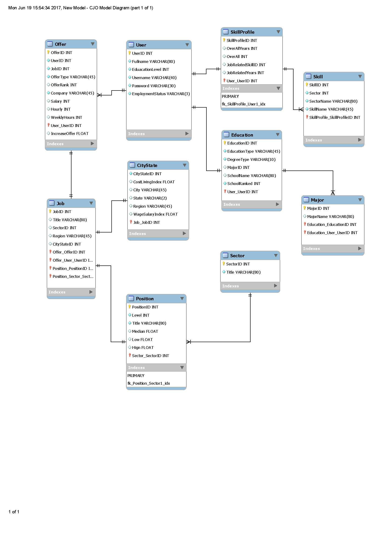

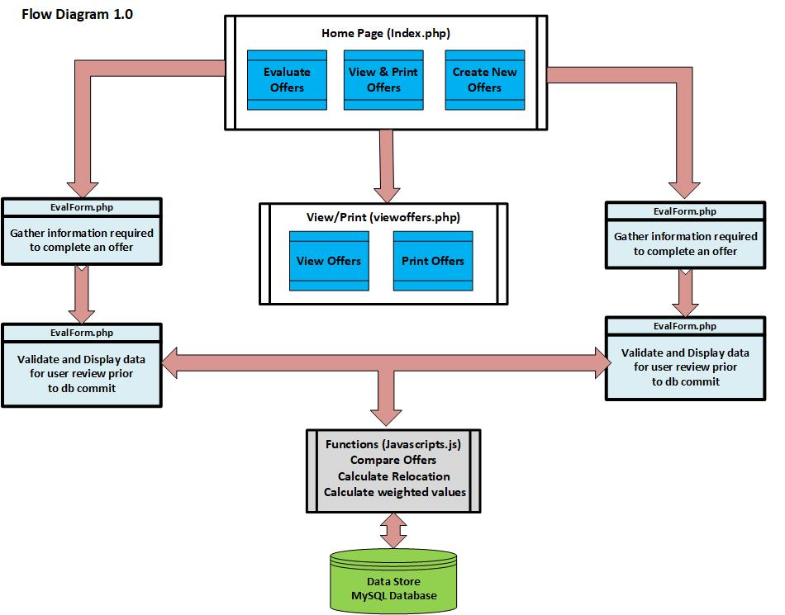

**Converting Full Time Pay to Hourly Contract Rate – (JavaScript.js functions)**

Multiple people asked me this week how much they should charge for an hourly development engagement, trying to figure out what’s fair. They all know their full time salary range but didn’t know how to translate that into self-employed hourly rate. This post is a quick explanation of the formulas I use. This is obviously not an industry standard or what your next employer (or employee) is going to use but you might find it a useful reference point. This is limited to US based employment.

Needless to say, these formulas ignore the many employer tax differences of employing W-2 vs 1099 employees. They are also ignoring the most important factor which is the human element. We are talking about people hiring other people where unique skill sets, personalities, and economic realities can often mean more.

There are two types of hourly employees, those you can easily replace with full time people and those you can’t afford (or can’t convince) to work for you as W-2 employees. For the first group, the hourly rate is based on the employer cost of a full time person. Basically, the employer will want to keep its cost about the same regardless of the employee status.

Assuming:

* 20% employer overhead cost over the employee cash compensation for

benefits, taxes, and other expenses

* 250 work days a year
* 15 days paid vacation
* 8 hours work day

The formula is: **Hourly rate = Total annual cash compensation / 1567**

For the second group — people the employer can’t afford to pay full time or the kind of top talent they can’t convince to join full time — the formula is slightly different. There is an additional consideration. People doing short term contract work typically lose about 20% annually due to time in between jobs and the cost of finding work on a regular basis (a contractor factor of 0.80–20%productivity loss). Because they are top talent, the employer will have to pay for that loss. This gives us:

**Hourly rate = Total annual cash compensation / 1253**

The full formula is: A * E }{ (W — V) * H * C} $

A — total annual cash compensation

E — employer overhead percent (1.0 is 100%)

W — work days a year

V — paid vacation days or PTO

H — hours a day

C — contractor factor (percent time employed)

This means:

* An average developing making $120K a year would be able to get about $80/hour
* A senior expert making $200K a year would be able to get about $160/hour

If the fulltime job come with equity (assuming a 25% annual vesting schedule of a publicly traded stock), you can add 25% of the equity value to the annual salary.

## **Personal time off (PTO)**

|  |  |  |  |  |
| --- | --- | --- | --- | --- |
| **POLICY NAME** | **EARNED YTD** | **USED YTD** | **CURRENT BALANCE** | **ACTION** |
| [Assign/Create Vacation Policy](https://payroll.suntrust.com/spf/Employees/Edit/12) | Available when a policy is assigned | | | |
| [Assign/Create Sick Policy](https://payroll.suntrust.com/spf/Employees/Edit/12) | Available when a policy is assigned | | | |
| [Assign/Create Other Policy](https://payroll.suntrust.com/spf/Employees/Edit/12) | Available when a policy is assigned | | | |
| [Assign Holiday Policy](https://payroll.suntrust.com/spf/Employees/Edit/12) | Available when a policy is assigned | | | |